DOCKER_TASK_2
Tasks:
❖ Create a tomcat container on 8080 and deploy sample application in tomcat.
❖ Create volume and deploy tomcat container on port 8081.
❖ Limit the nginx container to 500 MB.
❖ Create a sample docker file using below instructions.
❖ Base module as amazonlinux:latest
❖ Maintainer you name
❖ Install nginx
❖ COPY one index.html file to image
❖ Expose on port 80
❖ Command to start the nginx container
❖ Push image to Docker hub
❖ push image to AWS ECR
1. Create a tomcat container on 8080 and deploy sample application in
tomcat.
→docker pull tomcat:latest
First download latest imgaes of tomcat
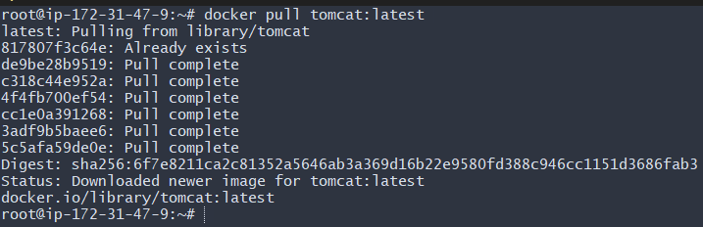
Now lets check our tomcat as you see photo it visible on tomcat with conatiainer id image
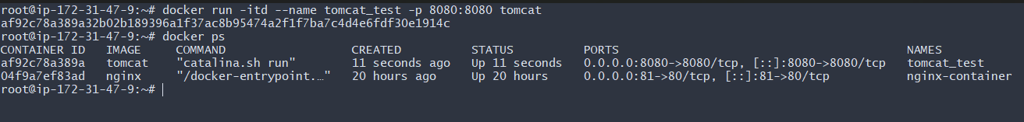
now lets test tomcat yea working on port 8080 also the container id copy id type ducker exec -it that id /bin/sh if in terminal # symbol that means we are in now in container tomcat
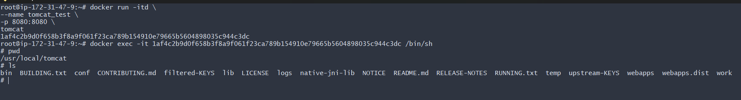
Lets upldate it also
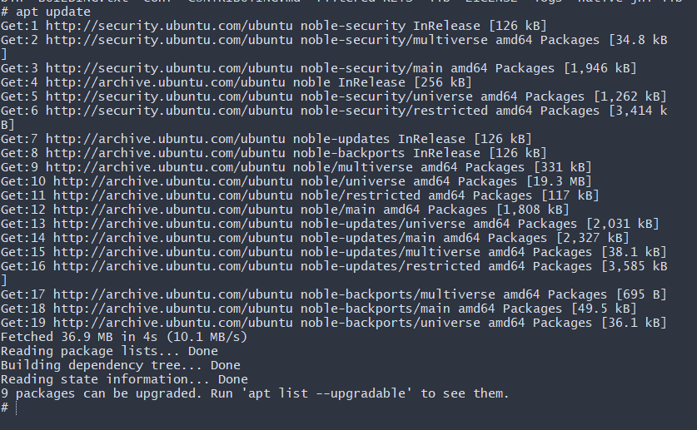
now lets install wget on for sampleapps
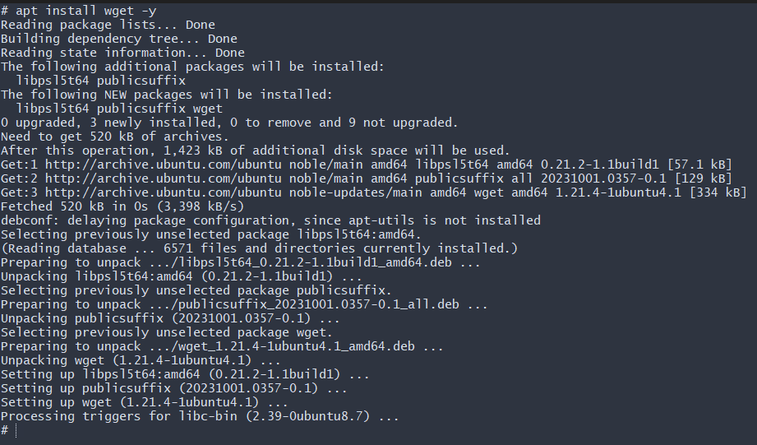
Now lets install sample.war on you tomcat
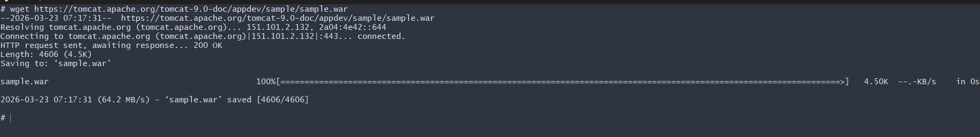
Now lets go web copy public ip and port is our 8080 as see it showing 404 not found last apache tomcat with version
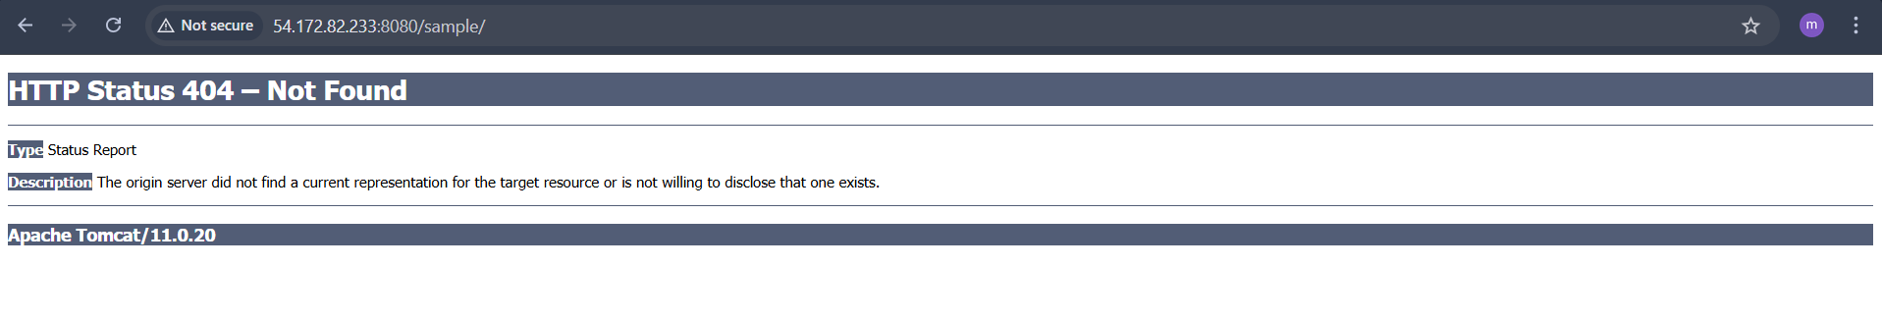
2. Create volume and deploy tomcat container on port 8081.
→docker volume create deployment
→docker volume ls
→cd /var/lib/docker/volumes/deployment/_data#
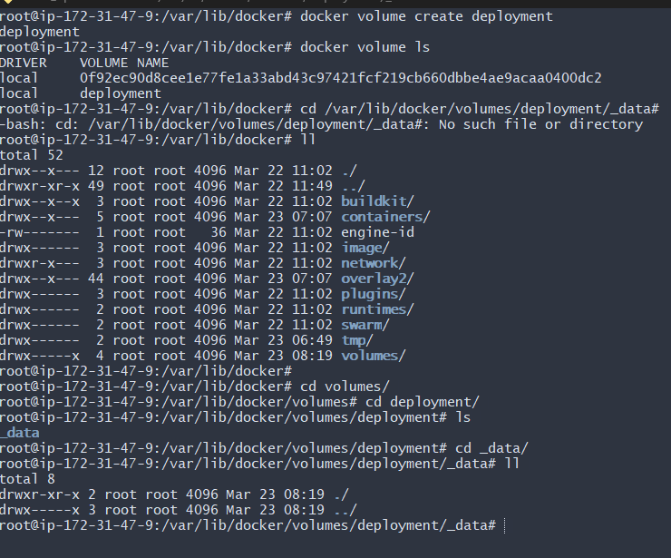

docker container run -itd -p 8081:8080 -v /var/lib/docker/volumes/deployment/_data:/usr/local/tomcat/webapps tomcat:latest
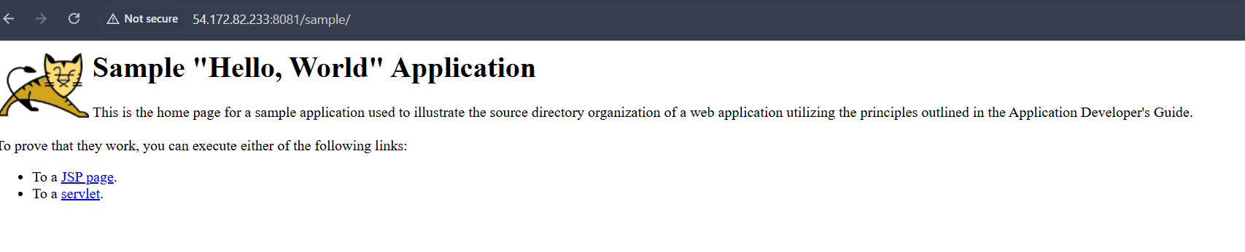
3. Limit the nginx container to 500 MB.
→ docker run -d --name nginx500 -p 80:80 --memory="500m" nginx
4. Create a sample docker file using below instructions.
5. Base module as amazonlinux:latest
6. Maintainer you name
7. Install nginx
8. COPY one index.html file to image
9. Expose on port 80
10. Command to start the nginx container

Create a dockerfile and do below tasks
1.Base module as amazonlinux:latest. Task 5
2. Maintainer you name task 6
3. Install nginx task 7
4. COPY one index.html file to image. Task 8
5. Expose on port 80 task 9
6. Command to start the nginx container task 10

→Step1: mkdir nginx-task
→cd nginx-task
→ vi index.html
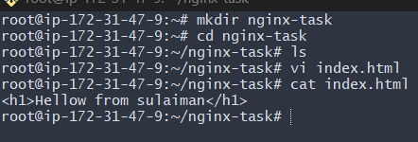
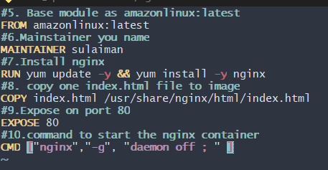
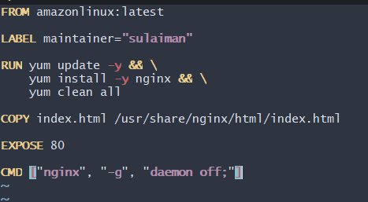
→ Step 4: Build Docker Image → docker run -itd --name arj-nginx -p 9090:80 arj-nginx:1.0
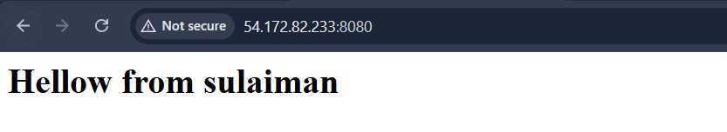
11. Push image to Docker hub
→Create a docker account sign up and login
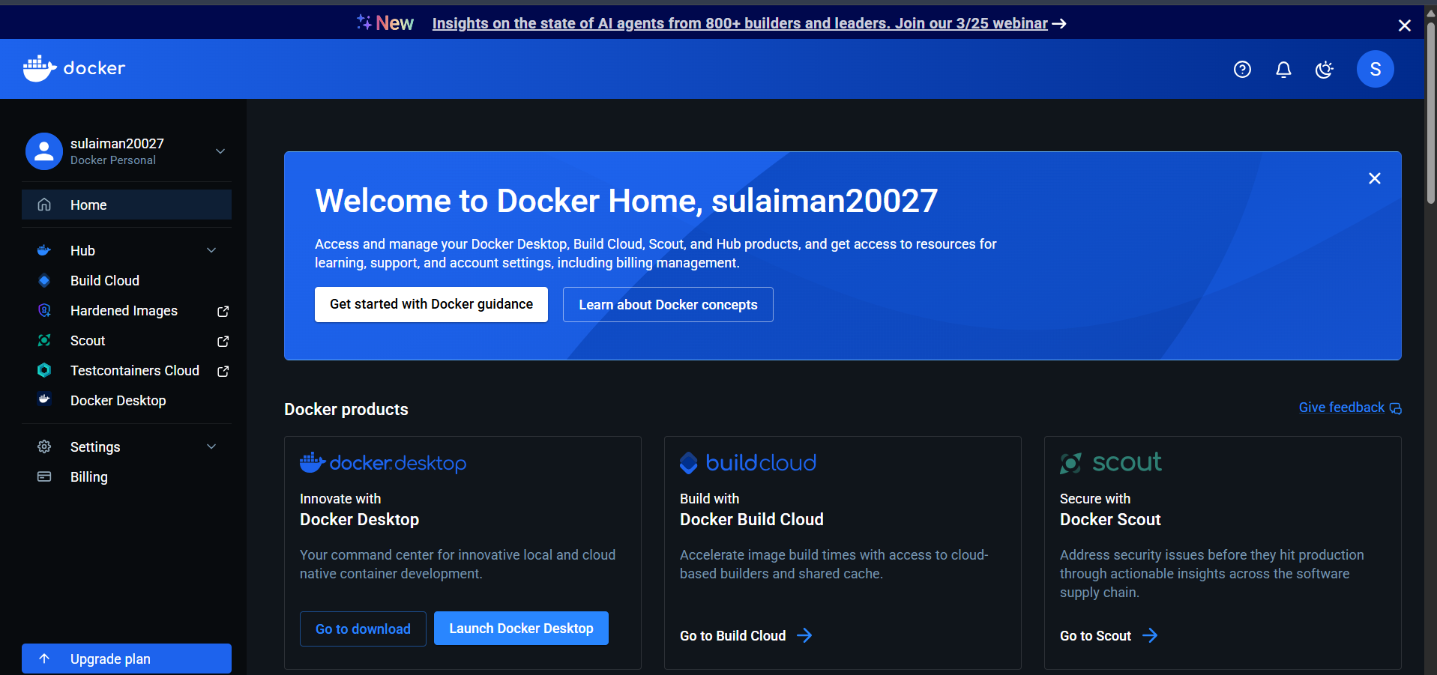
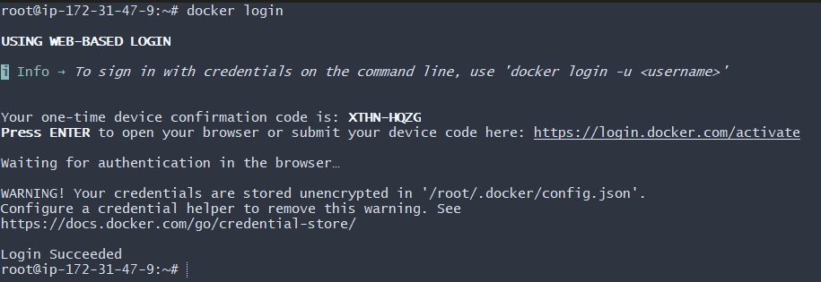
👉 Step 1
docker login

👉 Step 2
docker images

👉 Step 3 (CHANGE NAME TO YOUR USERNAME)
docker tag nginx sulaiman20027/arj-nginx:1.0

👉 Step 4 (PUSH)
docker push sulaiman20027/arj-nginx:1.0

👉 Step 5 (VERIFY)
Open browser:
https://hub.docker.com/
👉 Go to your repos
✔️ You will see your image
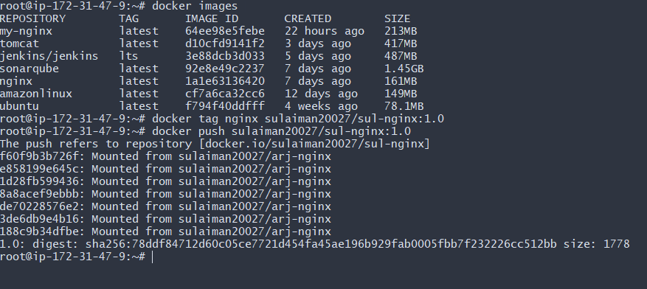
Now see we successfully created our nginx repo in docker

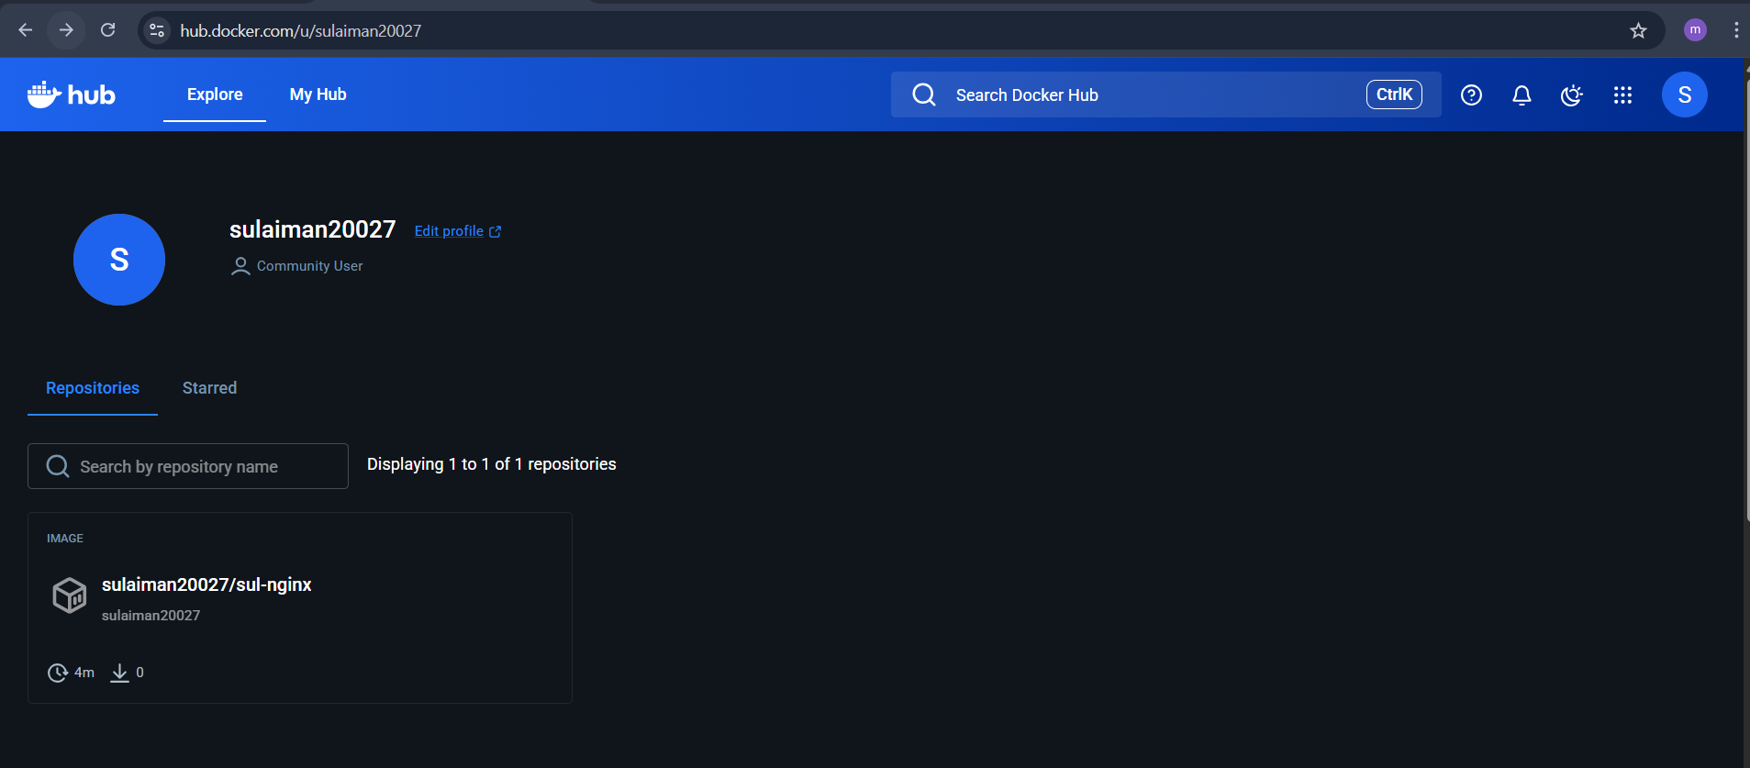
12. push image to AWS ECR
→ sudo apt update
→sudo apt install -y unzip curl
→curl "https://awscli.amazonaws.com/awscli-exe-linux-x86_64.zip" -o "awscliv2.zip"
→unzip awscliv2.zip
→sudo ./aws/install
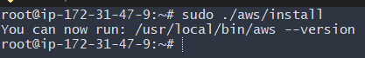
Now configure your aws accont using aws configurae type access and secrent acces key region ap south 1 format json then press enter
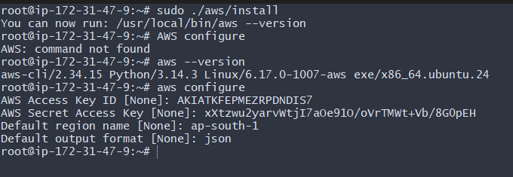
tep 3: Verify AWS Account ID
aws sts get-caller-identity

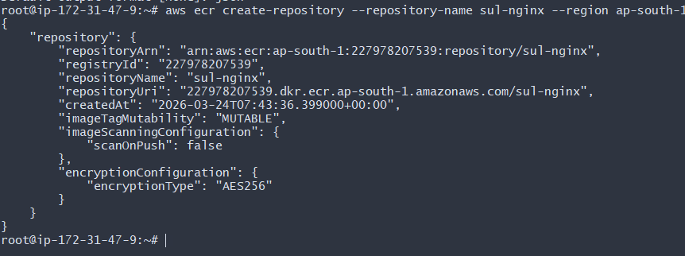
Step 4: Create ECR Repository
aws ecr create-repository --repository-name sul-nginx --region ap-south-1
🔥 Step 5: Login to ECR
aws ecr get-login-password --region ap-south-1 | docker login --username AWS --password-stdin 227978207539.dkr.ecr.ap-south-1.amazonaws.com

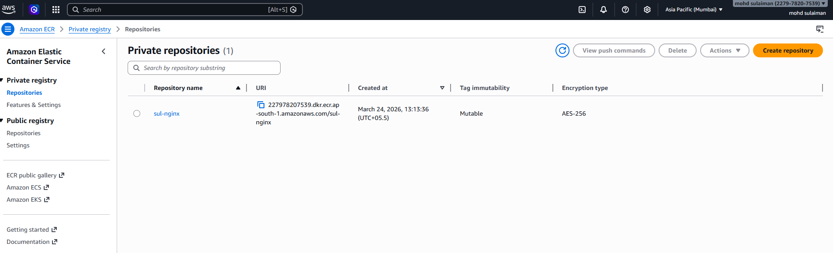
Step 6: Tag Docker Image
docker tag nginx 227978207539.dkr.ecr.ap-south-1.amazonaws.com/sul-nginx:1.0

Step 7: Push Image to ECR
docker push 227978207539.dkr.ecr.ap-south-1.amazonaws.com/sul-nginx:1.0

